Bearpool, A carpooling application for students

## Team G

Knox Brown

Durgam Abilash

David Neufeld

Kledis Zaimi

Quinn Knowles

John Kearney

Tiffany Ha

# Problem

Students living off campus without a vehicle deal with the daily struggle of trying to get to class on time. Any student living off campus without a vehicle deals with the daily struggle of trying to get to class on time.

If there was a carpool system, it would open up space in the parking lots. It would also make it more accessible and convenient to get to campus. Without a reliable source of transportation, students often end up missing class time. Solutions like Uber, Lyft, and the BBOE are effective for some, but not all. While Lyft and Uber can be great options on an emergency basis, paying for a ride to and from campus multiple times per day simply isn’t sustainable for most college students. The BBOE arrives every 30 minutes, making travel stressful for students reliant upon it for transportation. How can students arrange rides to and from campus at their requested times by carpooling with other students?

# Prior Solutions

## Solution 1: Uber & Lyft

Uber is a previous solution to the problem. It is a ride-sharing app that allows users to request rides and earn money by offering rides. The shortcoming of this solution to our specific problem is the cost.

In a similar vein Lyft simplifies transportation by offering an affordable and reliable alternative to traditional taxis, public transit, and personal car ownership. Users easily request and track rides through an app, connecting with drivers quickly for on-demand travel. This reduces costs, provides convenience, and offers flexible options like carpooling, making urban and suburban commutes more efficient and sustainable.

**Why our solution is better:**

Our free carpooling app for students offers cost-free rides, making commuting affordable and accessible. Rides are given voluntarily by providers, creating a supportive community where students help each other with transportation needs. Drivers are compensated through tips from riders, promoting a culture of gratitude and shared responsibility without burdening students financially.

In our app, the driver will also be going to campus for school, and they don’t need to take time out of their schedule to give rides. The program will provide various tools to help users such as: location services, privacy settings, and ways to communicate pertinent information between equal users. Task specific features that Uber and Lyft aren't necessarily geared toward. The program will allow users who are riding with someone to tip their driver, however this tip will not be mandatory.

**Task Flow diagram:**

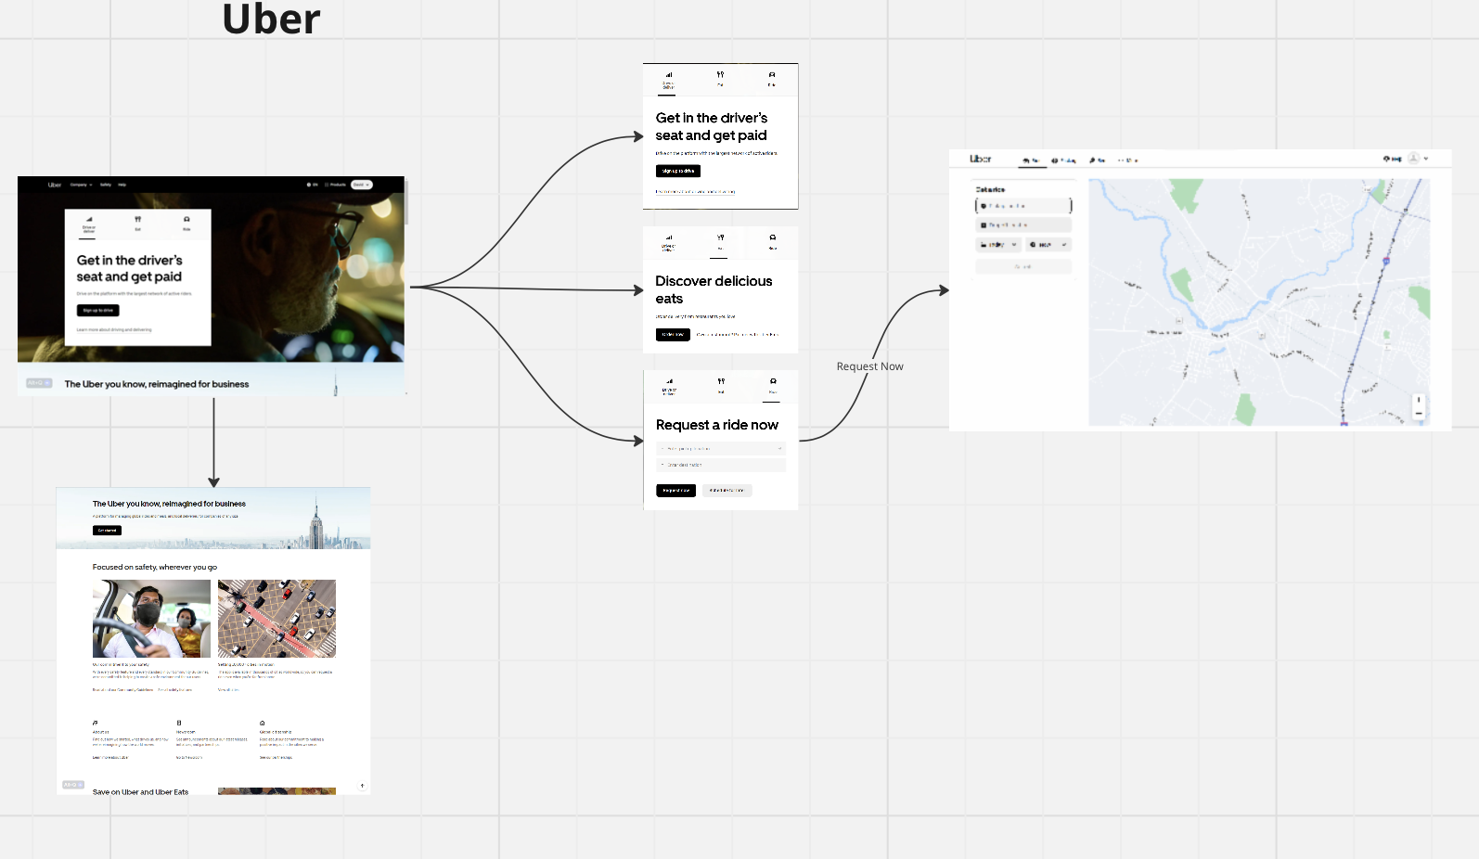

**Task flow diagram 2: Lyft**

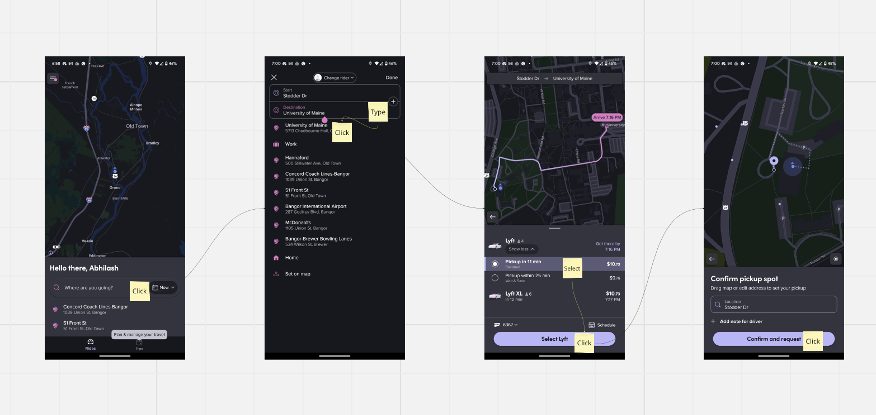

## Black Bear Orono Express 2

A previous solution to our problem is the Black Bear Orono Express. It is a public transportation method that runs for approximately 12 hours, from 6:20 AM to 6:10 PM. The bus offers transportation for the largest portion of the UMaine campus and is provided by the Bangor City Hall.

**Why our solution is better:**  
 The reason why our solution will be better than the Black Bear Orono Express is that it will be able to offer rides throughout campus for a longer period of time, as well as more efficiently in terms of time and locations provided. Waiting for buses is a time consuming process, especially if the bus schedule doesn’t line up with your own schedule. Consistent rides from a car pool will help students make better use of their time.

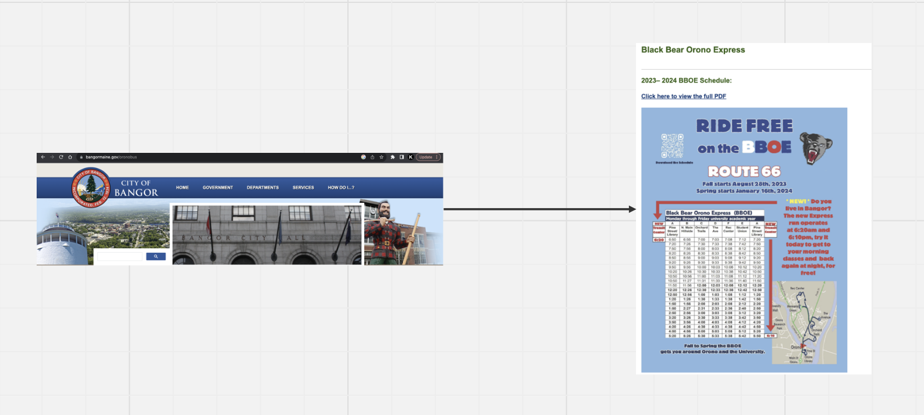

# Bearpool

Our app will provide rides to students, from students. It will be similar to other ride sharing applications but will only proctor rides to and from campus. All this, in an effort to help students without vehicles find transportation on a daily basis. The end goal of the app will be to match students up with those who have a similar schedule. This may take a few tries, but two students who have a similar schedule will likely continue making trips together for an entire semester.

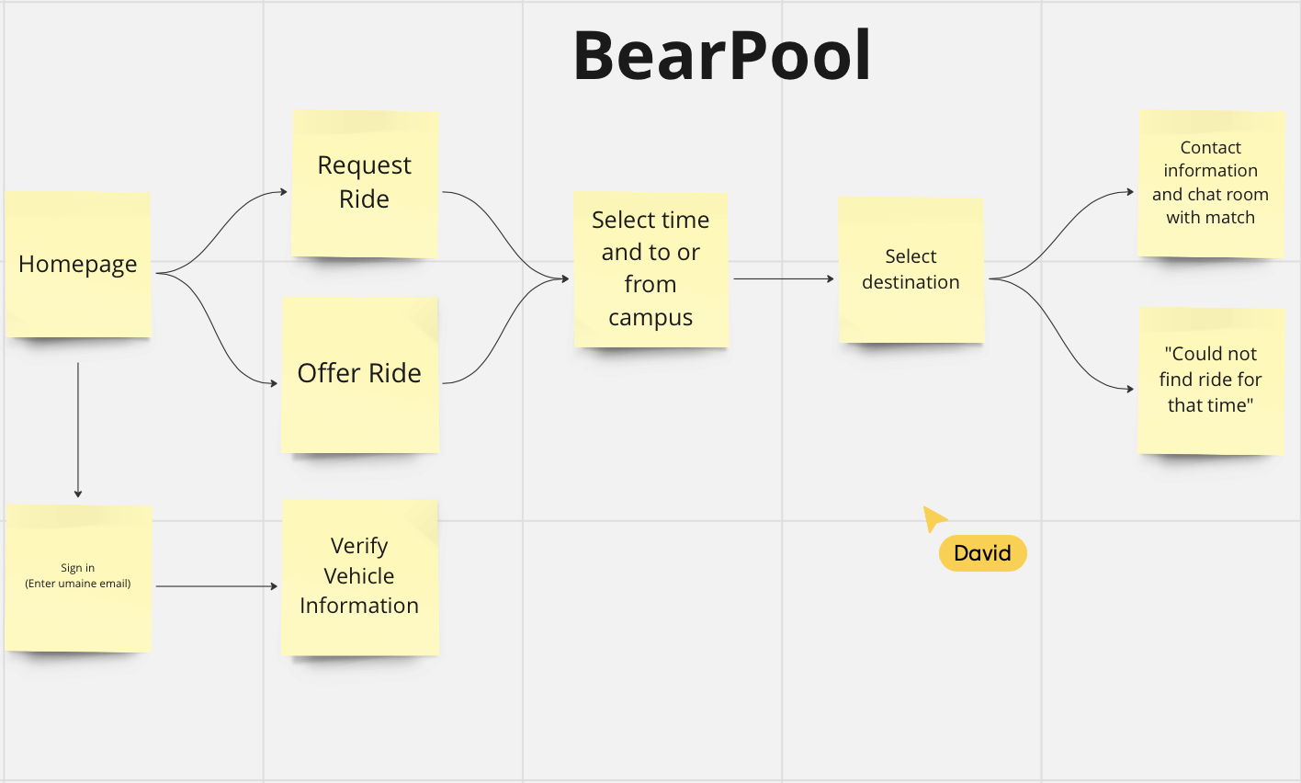

<https://miro.com/app/board/uXjVMgU4Jb0=/?share_link_id=183211366636#>

**The home page** will be easily accessible. Users will be able to clearly see their options and select from multiple large headers at the top. Users will be able to make an account, log into an existing one, search for rides in their area, update account information, learn more about the application and how it works.

**Request Ride:** This option is for users who want to be picked up by another student, or otherwise given a ride

**Offer Ride:** This option is for users who have a vehicle and want to offer a ride to another user.

**Selecting to or from campus:** In our app the user will be able to select whether they are traveling to the Umaine campus or going out of the Umaine campus.

**Select Destination**

In this page, the user will be able to select a destination for their ride. The destination can be either in campus or outside of it, depending on previous choices made by the user in previous steps.

**Contact information and chatroom:** Once there is a match we can set up communication with the users match.

BBOE : We will be different from this due to the fact that the bus currently arrives in 30 minute increments. Our team hopes the application will be able to offer rides to students at any given point throughout the day

Uber & Lyft : We will only be proctoring rides to and from campus. The key difference between us and other taxi replacing apps is that we will not charge money through the app. Drivers will have the option to provide a method of payment to passengers (tips) but there is no base fee that needs to be covered.